Model Building Importing the Model Building Libraries

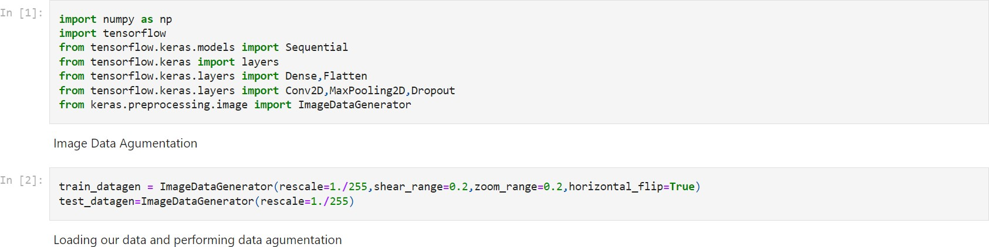

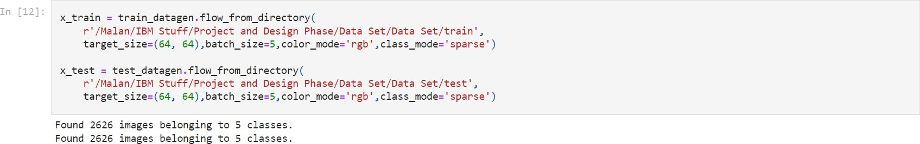

Initializing the Model



Adding CNN Layers

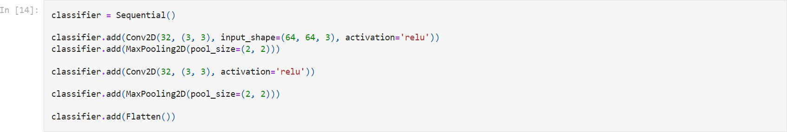

Adding Dense Layers

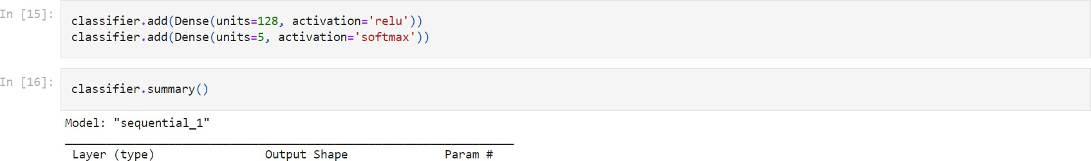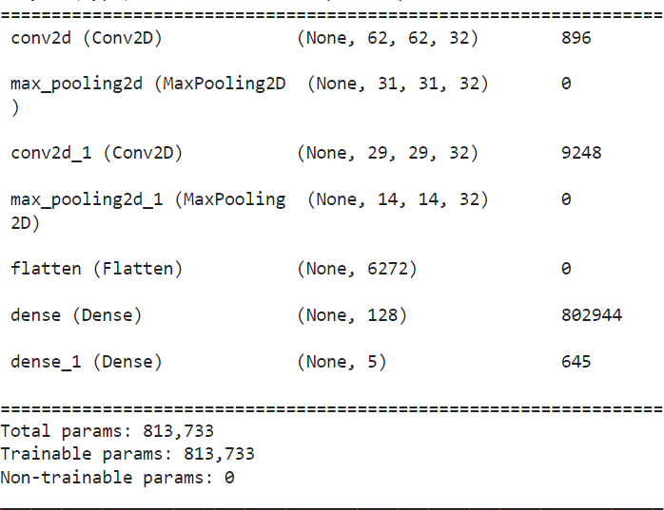

Configure the Learning Process



Train The Model

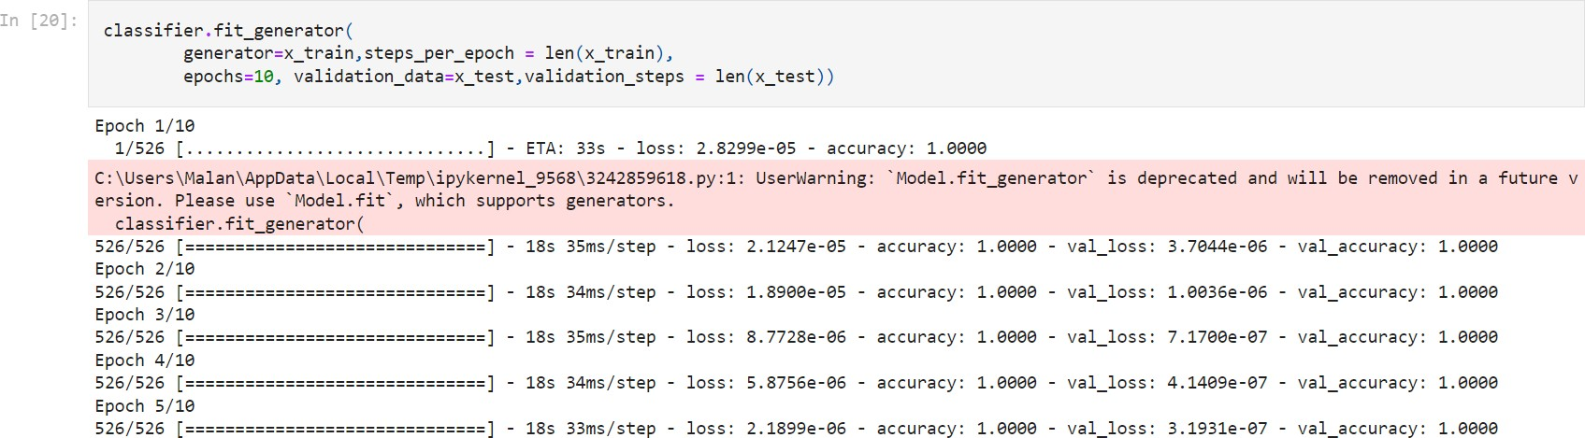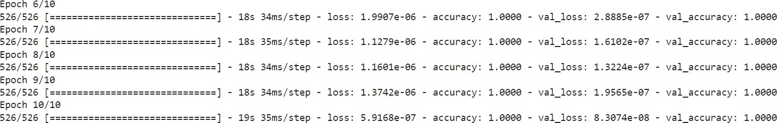

Save The Model



Test The Model

